Keppel Land
Customer Centricity Engagement

August 6, 2022

Table of Contents
What you are focused on Achieving 3
What You get From our Work 3
Customer Centricity 4
Customer Centricity: Your Differentiator 4
Shifting the mindset: The customer Centric Methodology 4
Strategic Engagement Pathway 5
Strategic Engagement Pathway with Deliverables 6
Current State- Discovery 6
Building the Future State- Defining the Vision-TO-Value Roadmap 7
install, Ennhance, Elevate- The Playbook 7
Investment for Performance 8
Time zone and Logistics 9
Time Frame Estimate 10
Team 10
Relevanet Experience 11
Client Engagements 11
VaLue Adds 12
13
Appendices 14

What you are focused on Achieving

We understand that there are very clear outcomes that you are focused on achieving in this engagement:
- Customer-centric approach and mindset.
- Engagement and alignment throughout the organization.
- Having the new approach, mindset, and processes to echo your mission, vision, and values
- Be relevant to customer and support and compliment shifts in business model as you move to ‘asset-light’ portfolio, as well as new business development, such as Senior Living.
- Having a well-defined future state and playbook to ensure understanding, execution, and outcomes.

What You get From our Work
Given what you care about and what you are focused on, this is what we bring to make that become a reality:
- Discovery in the Current State that includes a deep dive into market conditions, market positioning (SWOT), current customer sentiment and segmentation, AND looking at your aspirational customer to become further future proofed.
- Define the Future State; a Vision-to-Value Roadmap that clearly defines “the new way to work”
- Develop: A Playbook of Installing and Enhancing with:
Foundation: The New Way to Work
Framework: The Tools and Resources needed to make the uncommon habit
Focus: How to coach, manage, and hold accountable the new foundation to ensure business outcomes
- A proven and pragmatic approach that has brought business results in other organizations yet is customized to Keppel Land’s vision and values.
What bring enables and ensures:
- Chosen business outcomes.
- Customer Centric mindset that ‘future proofs’ the business.
- Be relevant to the customers that are the most valuable to you.
- Ability to flex and shift business without losing the foundation and customer centric approach. 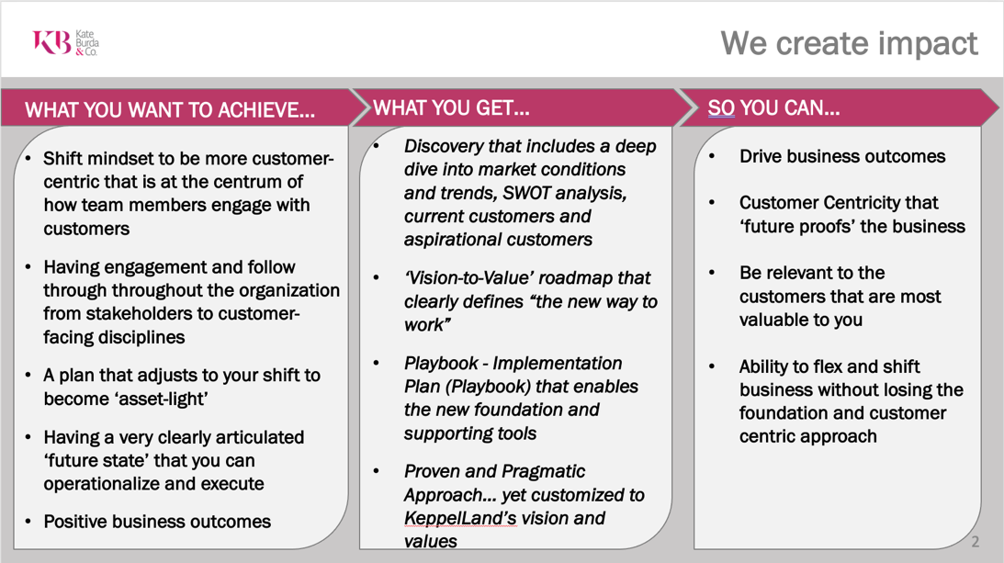

Customer Centricity

Customer Centricity: Your Differentiator
Insight 1: If you build a process without having knowledge of what your customer’s care about or what drives their satisfaction, you are not customer centric.

You have only created another internal message that may not be tied to your customers at all.

Customer Centricity is at the forefront of everyone’s mind, and many believe that they are. But they start the work thinking about their products and service, which is on complete other side of the spectrum than what their customers care about or seek.

What the best do differently is understand to be customer focused organizations must have an outside in thinking or ethos.

Outside in thinking takes a deep dive into what your customers want most, particularly the customers that are the most valuable to your business and strategic growth.

Shifting the mindset: The customer Centric Methodology

Where organizations fail in customer centric thinking is when they think about themselves first. Whether that is their products, services, processes, or even their values.

They start with thinking about their products and services, then explain to the customer how that fits in to what the customer is wanting. See figure 1. When teams work from left to right, they are only trying to convince customers and ultimately themselves that what they have is what the customers need. (The solid line)

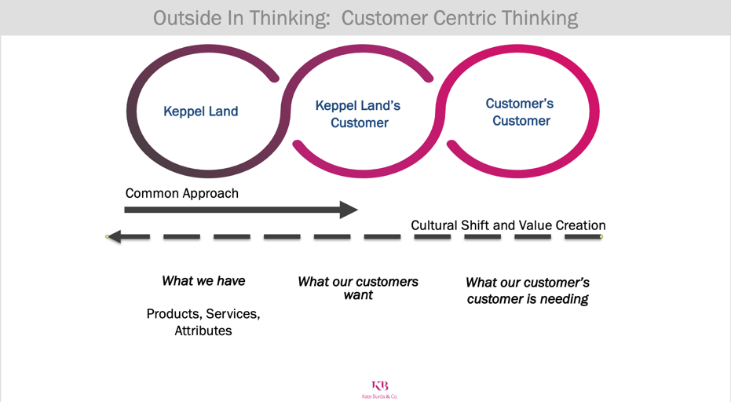
We take a completely different approach and not only look at the customer, but the customer’s customer. Working from right to left. (The dash line) This is a cultural shift and creates value for the customer.

This is true customer centricity.

Here is an example:

A golfer, possibly one that is going to visit Spring City Golf Course. In the first approach, that we see all too often, they start talking about the golf course, the designer, the events they have hosted, the list goes on.

If we were to reverse engineer to create value and have shift mindset, we would look at the customer’s customer. In this example it is the golfer’s family. What the family cares about is having memories and creating experiences during their time away. Working left we understand that they golfer may care about bragging about where they played or checking off box of courses or places they placed. This outside in thinking changes how we engage, approach, and see our customers differently.

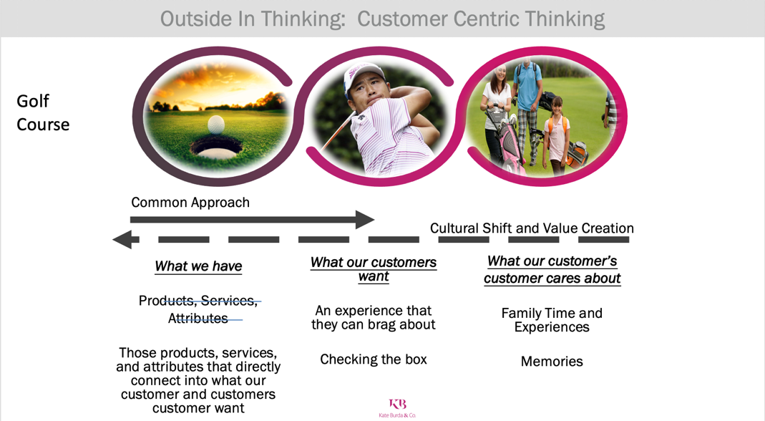
Insight 2: Why is the customer’s customer so important to our customer-centricity work? Because if we make our customers and clients successful, important, and valued by their customer, they will become a lifetime customer of Keppel Land.

This thinking and approach are core to how we define and develop the Keppel Customer Engagement model.

Strategic Engagement Pathway
Below illustrates the pathway that has worked in programs very similar to Keppel Land to ensure impact:
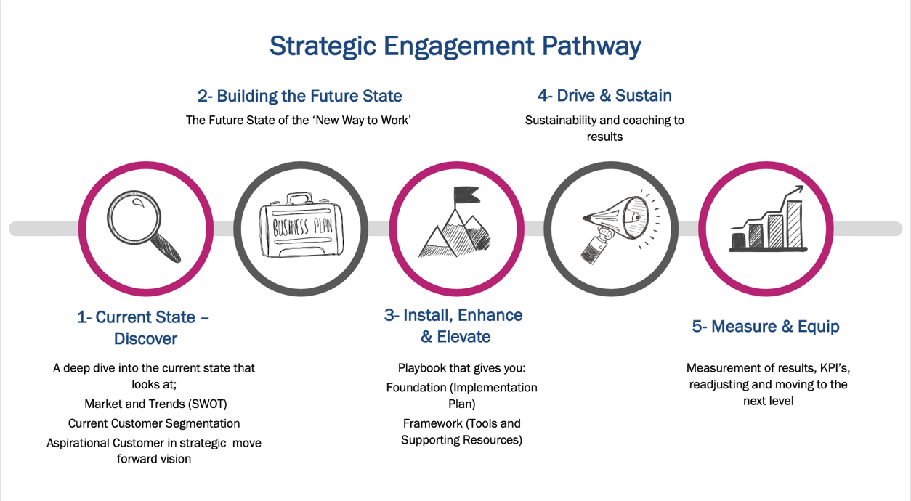
The Drive and Sustain (4) and Measure and Equip (5) are not currently within the scope of work but can be later included.

Strategic Engagement Pathway with Deliverables

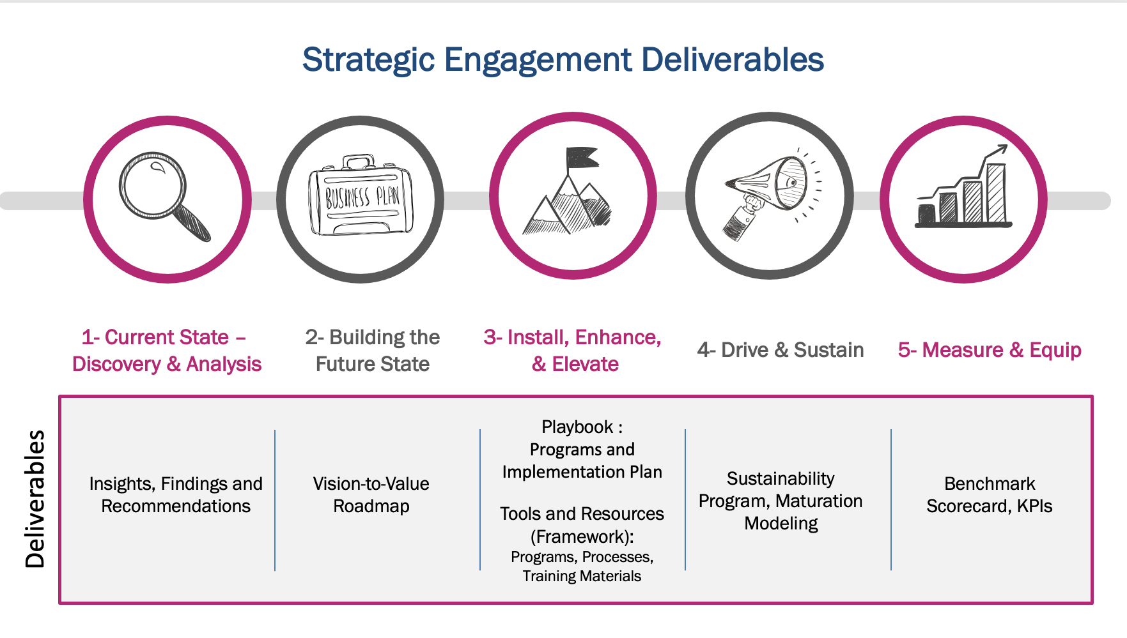

Current State- Discovery

Work being done within Current State- Discover

We are taking a deep dive into both internal and external forces in four distinct areas:
- Keppel Land’s Internal Strategy and Alignment
  - Strategy and Vision
  - Current programs, such as the 3C’s and RED
  - Alignment
  - Internal Competencies

- Current Customer Engagement
  - Current Customer Segmentation
  - Current Customer Experience by segment
  - Value Proposition
  - Processes
  - Systems

- Market Analysis
  - Market Positioning (SWOT)
  - Trend analysis

- Aspirational Customer
  - New Customer Acquisition plans
  - Potential Customer segmentation
We do this by surveys, interviews with the ‘critical crowd’ and data analysis.

What deliverables an outcome of the current state
- Current State Benchmarking / Heatmap
- Outcomes, Insights, and Recommendations

This enables us to see areas of effectiveness and what is working, what isn’t working and needs to be left behind, and what needs to be built.

Gives us insights on what the best do differently in core areas

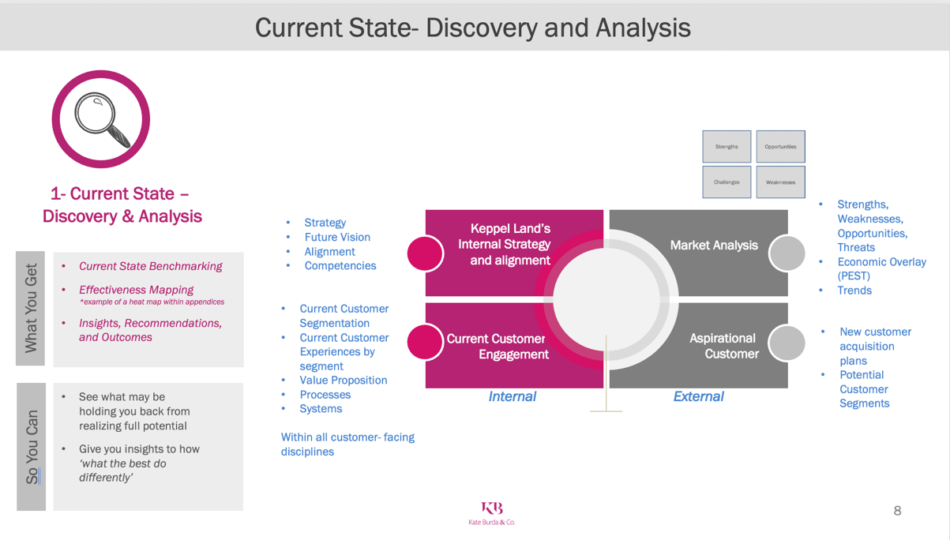

Building the Future State- Defining the Vision-TO-Value Roadmap

Work being done in building the Future State
Using the data, information, trends, and inputs from the Discovery phase we will put together a Vision-to- Value Roadmap that clearly defines the ‘Future State’ and the ‘New Way to Work’. The roadmap illustrates:
- Strategic Initiatives
- Aspirational Position in the marketplace
- End goals and possible metrics
- Supporting Initiatives
- Involved teams and resources

Deliverables of Future State:
- Vision-to-Value Roadmap
- Stakeholder and team alignment and vetting

*Illustration of Roadmap in Appendices

install, Ennhance, Elevate- The Playbook

Work being done in Install, Enhance and Elevate:
We design and develop the playbook that includes programs, systems, tools, and resources needed to drive the program, so you and your team can implement.

The deliverables for Install, Enhance and Elevate

The foundation of programs, learnings, systems for the ‘new way to work’ which includes The Playbook
The framework of tools and resources that are needed to help sustain and make the uncommon habit.
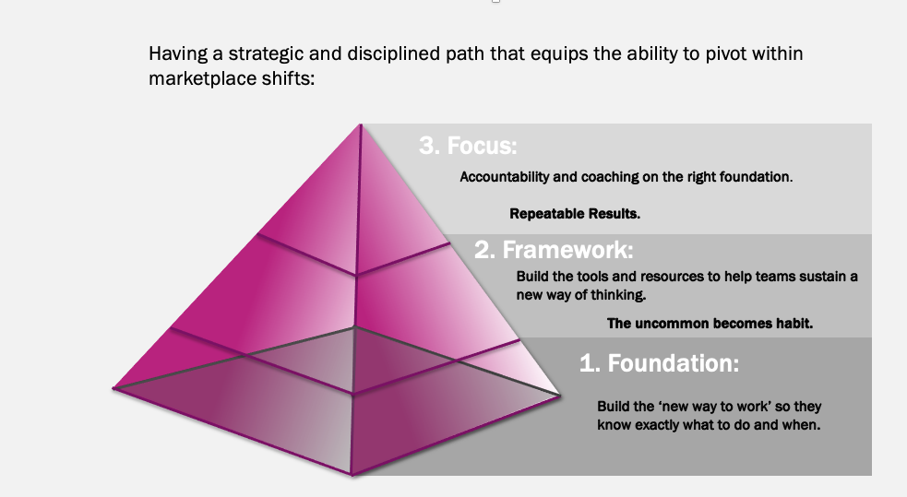

Investment for Performance

Kate Burda & Co will conduct this effort with respect to the quality of deliverables and budgetary constraints.

To manage better this effort with full transparency and accountability, we propose a cost-plus time & materials schedule to help control expectations and fiscal oversight.

The effort will be planned and scheduled with oversight to help track and manage the planned versus consumed hours. Given the complexity and variable effort, hours will be allocated and billed in monthly 100-hour increments.

Effort provided and consumed over the monthly 100 hours will be billed as consumed.

Below is an expectation of hours needed per phase and approximate cost. Investment costs depicted in the below estimate quoted in Singapore dollars. However invoices and payments will be in USD$

The below illustrates an estimate of effort for each phase. Estimates can shift based upon approved scope of work.

Costs do not include travel expenses.

Time zone and Logistics
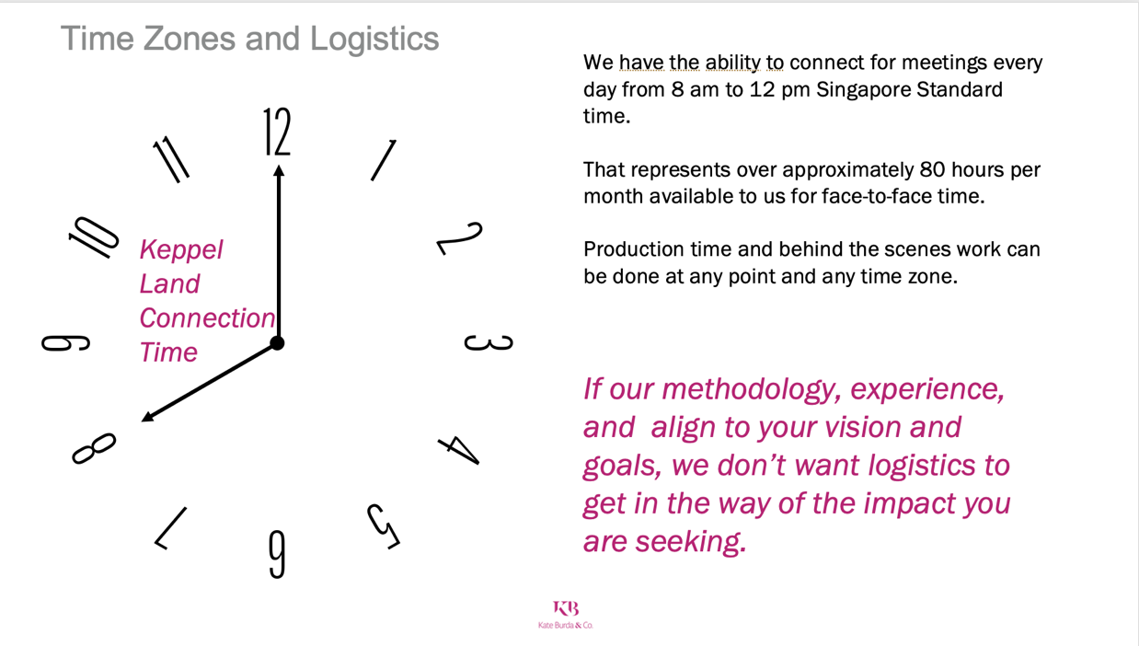

Time Frame Estimate

We believe we can deliver the work that we understand within 6 months. However, there are variables that could shift that timing, such as: client availability, access of information, and approved scope of work. Below is an illustration of how that 6-month time frame will be allocated.

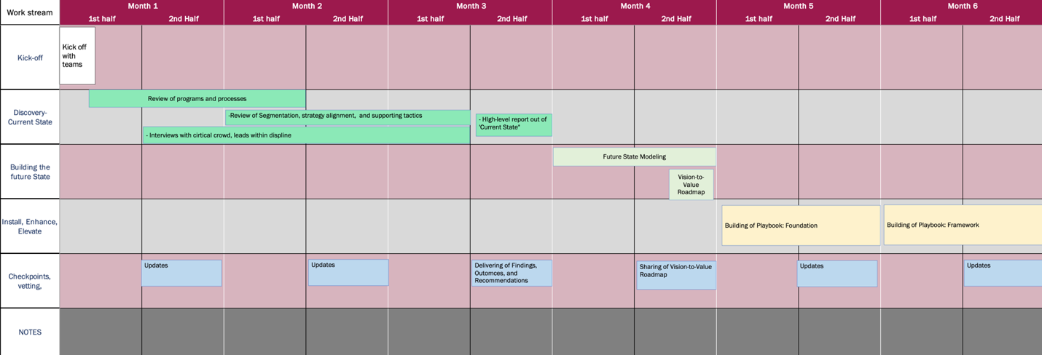

Detailed timeline would be designed within project management.

Team

Based upon what we understand we would have key roles to your project:

Client Lead and Managing Partner: Kate Burda
Project Manager: Carly Walsh
Research and Analysis: Tristan Carty / Chuck Coveleski

Each player has deep experience in strategy and transformation, as well as their expertise. We can furnish more background as we move further in conversations.
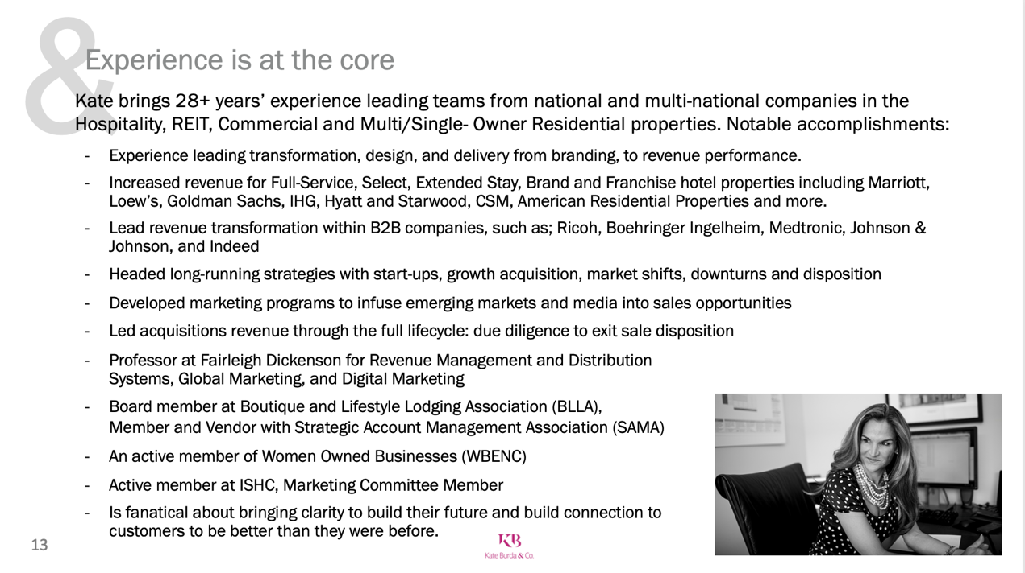

Relevanet Experience

Strategy Transformation:

IHG- Global Customer Engagement Program with Service and Sales teams
- Transformed approach to sales and service models, including training programs and on-boarding of new employees.
- Geographies impacted: Europe, EMEA, APAC

Abbott Labs- Sales and Marketing Customer-centricity; launching of a new product line
- Redesigned and Delivered sales and marketing approach for Abbott labs
- Geographies: Middle East / Africa, Europe, LATAM, APAC

Real Estate Investment Trust- Strategy Transformation and business line development
- Designed, developed, and implemented customer service models, sales approach, branding, and built customer journey that enabled marketing programs
- Real Estate portfolio included: Hotels, Multi-family, commercial, and retail space

Ricoh- Strategy transformation; moving from a copier company to a service, consultancy model
- Designed, developed, and implemented customer service models, business line development, customer sales approach, distributor models, and technology systems.
- Geographies: North America and APAC

Client Engagements

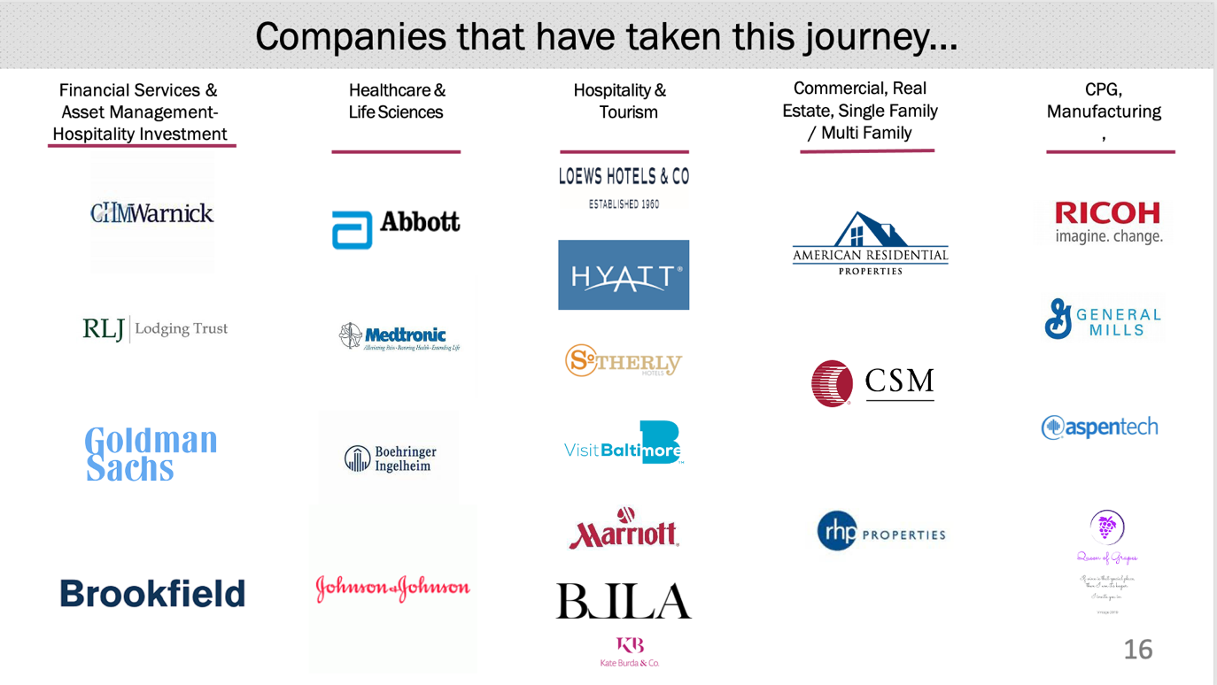

VaLue Adds

What we can add of value to the engagement:

- Sales Process Methodology and Training (IP)
- Marketing enablement programs, Customer Journey Mapping (IP)
- Ignite- A SaaS program that enables Revenue Strategy
- Ability to lead and conduct training, both in person and virtually

Kate Burda & Company is entirely focused on co-creating a strategic plan with you to drive economic impact to Keppel Land

What differentiates us?

- We have a proven strategic experience and methodology of how to develop, communicate and bring the plan to life.

Why you should care:
The work of this plan can be complex, confusing with many parties involved with their own opinions, and interests. It can get upside down quickly. Our goal is not only to have the right strategic plan, but to bring clarity and simplicity all parts of the journey.

“Clarity is momentum with no resistance in it” -Abraham Hicks

- We have methodology and thinking that enables those people to think differently to have the foundation to execute, the framework to make the make the new thinking habit, and the focus (cadence, accountability) to help them understand, mobilize, and execute the plan.

Why should you care:
We could build plan that is differentiated and the right pathway. However, if team can’t understand, have the mindset to mobilize, or have the foundation and framework internally the plan was just an exercise.

Kate Burda & Co has the methodology and thinking to achieve something they have never done before. We go beyond the plan and help the critical crowd to achieve goals set forth in the strategic plan. Better yet, they become stronger as a result.

“The best laid plans of mice and men often go awry” – Robert Burns.

- We have a depth of strategic experience both inside and outside of the real estate space.

Why should you care:
To be differentiated and relevant, it is critical to partner with teams that approach things ... well, differently. Kate Burda & Co will bring in new and provocative thinking. We know what works in other spaces, industries, and geographies. Maybe more importantly what doesn’t work.

“In a sea of sameness, choose to differentiate”

Appendices

Vision-to-Value Roadmap- illustrative

